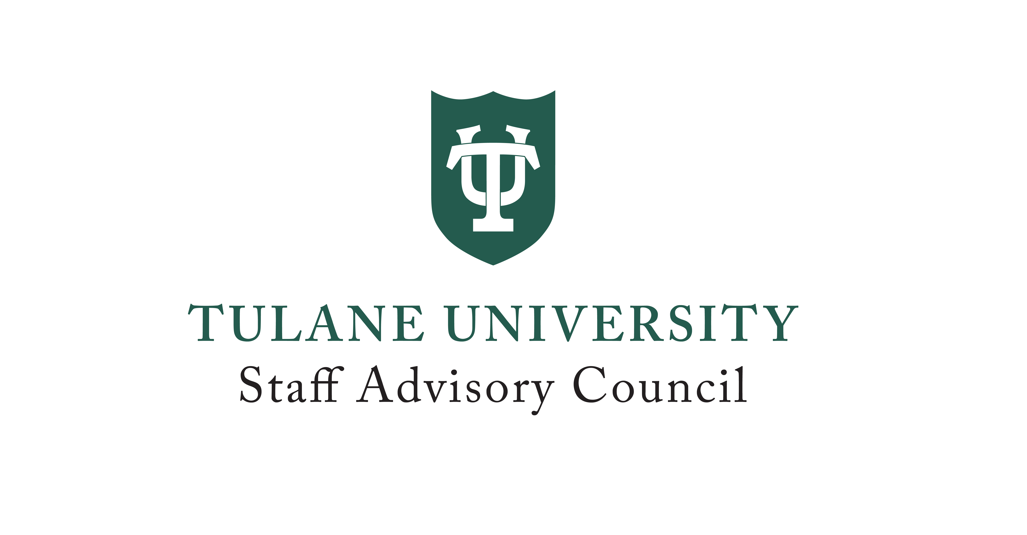
The Tulane Staff Advisory Council Meeting Minutes
Tidewater Diboll Gallery, 1440 Canal Street
August 20, 2026
Present: Nancy Anderson, Trina Beck, Lesley Bertrand, Bethany Branson, Genevieve Burguieres, Rosalind Butler, Robert Carter III, Joey Couvillon, Natalia Daar, Sarah Entress, Will Ferbos, Christine Fisher, Jason Fujinaga, Bobbie Garner-Coffie, Benjamin Griffith, Katherine Gruber, Crystal Guillemet Davis, Dale Hall, Michelle Illidge, Laura Kreller, Amanda La Bella, Mary Letsch, Danielle Martin, Marie Maywalt, Analene McCullough, Ted Moree, Kalil Mosquera, Dyaisha Orgah, Desiree Packard, Angelique Smith, Wendy Stark, Tyrus Stewart, Alexa Sturtz, Elizabeth Tierney, Tyler Tran, Phillip Williams
Absent: Jade Byrd, Catie May Carey, Nina Cortes, Leisha DeRiso, Tara Desko, Ashley Ernst, Harrison Giese, Becky Gipson, Todd Gitlin, Theresa Glissman, Samantha Grabert, Brenton Guerin, Dr. Cara R. Guilbeau, Katherine Hague, Korey Lane, Brayden Luneau, Jason McFarland, Valerie McGinley, Diana Noveck, Larry Overton, Shawn Potter, Amelia Prados, Ashley Robison, Stacey Stanson, Daniel Senentz Jr, Douglas Stream, Carl Thomas Jr, Ashley Toney, Austen Williams

Agenda
- Call to Order
Phillip Williams, SAC Chair called the meeting to order.
- Roll Call of SAC Representatives
Attendance was captured through sign-in, and formal roll call was waived.
- Review and Approve Minutes
July meeting minutes were approved as presented and will be posted to the SAC website.
- Announcements from HR – Mary Leitch
HR Wave Works help desk is now live. Employee Listening Sessions facilitated by external consultants have begun with 80 person in-person sessions. Members discussed confidentiality, participation, and future survey opportunities with consultant Jason Greer.
Upcoming dates:
  - Employee Resource Fair (Sept. 10)
  - Professional Development Week (Sept. 21–25)
  - Employee Appreciation Week (Oct. 19–23)
  - Employee Appreciation Football Game (Oct. 24)
  - Staff Recognition Social (Dec. 10).
- Officer Reports
No significant reports were provided from the University Senate Committee or the Board of Tulane University as committees had not yet reconvened.
- University Committee Reports
- Budget – Has not met
- Committee on Committees – Has not met
- Equal Opportunity & Institutional Equity – Has not met, first meeting scheduled for Sept 23rd
- Faculty/ Staff Benefits – Has not met
- Information Technology – Has not met
- Physical Facilities – Has not met
- Social Issues – Has not met
- SAC Committee Reports
Community Service began planning for the annual Toy Drive and volunteer recruitment. Health and Wellness discussed expanding wellness resources and improving awareness of benefits. The Wave Works committee organized leadership, communications, and priorities for addressing staff concerns.

- Community Service – Roz Butler
Staff/Faculty Football Game – Will need SAC support
Toy Drive – Subcommittee meeting scheduled to meet to determine logistics and determine non-profit
- Health and Wellness – Bethany Branson, committee met August 18, 2026.
Discussed the cost of Reilly, opportunities to reduce cost for downtown employees and prioritizing top initiatives.
- Wave Works – Elizabeth Tierney, working to streamline ideas and potential asks for HR. Plans to submit top three pain points to facilitate change.

- New Business
  - Digital accessibility and Panorama
    - Members received an update from Bobbie on Tulane’s accessibility initiatives and Panorama implementation. Discussion covered WCAG accessibility requirements and the university’s broader accessibility initiative. Panorama will support accessibility for faculty teaching, Canvas sites and external resources.
    - Questions or support can be directed to panorama@tulane.edu.
  - Election results transparency
    - Motion from Ted Moree. “I moved that future election results for SAC representatives and proxies, including candidate names and vote tallies, be published to the SAC website and announced via the same channels the election itself was announced within one week of the polls closing”
    - Members discussed posting future SAC election results online within one week of the election.
    - Results should include representative and proxy/alternate totals. Results should be communicated through the same channels used to announce the election.
  - SAC communications and visibility
    - Roz Butler proposed creating a new SAC social media channel to increase engagement and visibility.
    - Support from communications was requested to help establish and maintain the channel. The group discussed opportunities to increase SAC visibility during employee orientation, including a SAC representative or HR presentation and a featured staff speaker.
    - Members also discussed including SAC communications as a regular meeting agenda item.
  - Affinity networks
    - Analene discussed opportunities to better utilize SAC’s relationships with the university’s 13 affinity networks. Members suggested exploring additional ways for SAC to engage with and support these groups including the annual report and listening sessions
  - Will Ferbos - Listening sessions are underway, with Will expecting to wrap them up by mid-September A summary of the listening sessions will be shared, with opportunities for continued dialogue at various levels.
- Adjournment
The meeting adjourned at approximately 4:30 PM.

